*FootyIntel AI*

**5.24 STAKEHOLDER ENGAGEMENT PLAN**

Revision 2

*12/6/2023*

**VERSION HISTORY**

| **Version #** | **Implemented**  **By** | **Revision**  **Date** | **Approved**  **By** | **Approval**  **Date** | **Reason** |
| --- | --- | --- | --- | --- | --- |
| 1.0 | *Eric Wnorowski* | *11/12/2023* |  |  | Initial Stakeholder Engagement Plan draft |
| 1.1 | *Eric Wnorowski* | *12/1/2023* |  |  | Updated version in accordance with all other document edits |
| 2.0 | *Eric Wnorowski* | *12/6/2023* |  |  | Final Revised Version |

**TABLE OF CONTENTS**

**1** **INTRODUCTION 4**

1.1 Purpose Of The stakeholder engagement Plan 4

**2** **STAKEHOLDER ENGAGEMENT PROCEDURE 4**

2.1 stakeholder identification 4

2.2 tools and techniques 2

2.3 stakeholder identification outputs 1

2.3.1 Stakeholder Register 1

2.3.2 Project Management Plan Updates 2

2.4 Risk Response Planning 2

2.5 stakeholder Monitoring, engagement, And Reporting 2

**3** **TOOLS AND PRACTICES 2**

**APPENDIX A: REFERENCES 4**

**APPENDIX B: KEY TERMS 5**

# **INTRODUCTION**

## **PURPOSE OF THE STAKEHOLDER ENGAGEMENT PLAN**

Plan Stakeholder Engagement is the process of developing approaches to involve project stakeholders based on their needs, expectations, interests, and potential impact on the project. The key benefit is that it provides an actionable plan to interact effectively with stakeholders. The overall purpose of this Stakeholder Engagement Plan is to ensure that a consistent, comprehensive and coordinated approach is taken to stakeholder engagement and project disclosure throughout the project.

This plan defines how stakeholders associated with the *FootyIntel AI* project will be identified, analyzed, and managed. It outlines how stakeholder engagement activities will be performed, recorded, and monitored throughout the lifecycle of the project and provides templates and practices for analyzing and prioritizing stakeholders. The Stakeholder Engagement Plan is created by the project manager (Eric Wnorowski) in the planning phase and is monitored and updated throughout the project. The intended audience of this document is the project team, project sponsor, management, and stakeholders.

# **STAKEHOLDER ENGAGEMENT PROCEDURE**

## **STAKEHOLDER IDENTIFICATION**

Identifying appropriate stakeholders for the project was relatively easy because of the relationship that exists between the firm and those who will utilize the product. These are stakeholders that have previously been involved in projects that FootyIntel has executed in the past. These relationships have stayed positive and will be essential to stakeholder engagement in this project. The main key to this process was identifying the specific range of the industry that will be the target consumer group.

During the construction of the Project Charter and Business Case documentation this group was identified through conversations with firm executives and research with consultants in the football industry. The business team identified which clubs/leagues/organizations would be expected to afford the minimum services provided by the project. The project will require a club to trial the product for a short period of time so that the project team can draw conclusions as to the quality and effectiveness of the product.

The enterprise environmental factors that can influence the Identify Stakeholders process include but are not limited to:

* Organizational culture, political climate, and governance framework;
* Government or industry standards (regulations, product standards and codes of conduct);
* Global, regional, or local trends and practices or habits; and
* Geographic distribution of facilities and resources.

The organizational process assets that can influence the Identify Stakeholders process include but are not limited to:

* Stakeholder register templates and instructions,
* Stakeholder registers from previous projects, and
* Lessons learned repository with information about the preferences, actions and involvement of stakeholders.

The project manager (Eric Wnorowski) working with the project team and project sponsors will ensure that stakeholders are actively identified, analyzed, and managed throughout the life of the project. Stakeholders will be identified as early as possible in the project so as to effectively engage with them. The steps for accomplishing this are outlined in the following sections. The project manager will serve as the Stakeholder Manager for this project.

## **TOOLS AND TECHNIQUES**

Expert judgment will be considered from individuals or groups with specialized knowledge or training in the following topics:

* Understanding the politics and power structure of the industry
* Knowledge of the environment and culture of the organization and other affected organizations including customers and the wider environment
* Knowledge of the industry or type of project deliverable
* Knowledge of individual team member contributions and expertise.

Data-gathering techniques will be be used for this process that may include but are not limited to:

* Questionnaires and surveys. Questionnaires and surveys can include one-on-one reviews, focus group sessions, or other mass information collection techniques.
* Financial analysis will be used to identify stakeholders and can include financial analysis from previous company projects that had similar target consumers.

Data analysis techniques can be used for this process that include but are not limited to:

* Stakeholder analysis. Stakeholder analysis results in a list of stakeholders and relevant information such as their position in the organization, roles on the project, “stakes,” expectations, attitudes (their level of support for the project), and their interest in information about the project. Stakeholders can include but are not limited to a combination of:
  + Interest
  + Rights
  + Ownership
  + Knowledge
  + Contribution
* Document analysis. Assessing the available project documentation and lessons learned from previous projects to identify stakeholders and other supporting information.

Data representation techniques may be used in this process. They may include but are not limited to stakeholder mapping/representation. Stakeholder mapping and representation is a method of categorizing stakeholders using various methods. Categorizing stakeholders assists the team in building relationships with the identified project stakeholders. Below a Power/Interest diagram will be used to understand the engagement relationship.

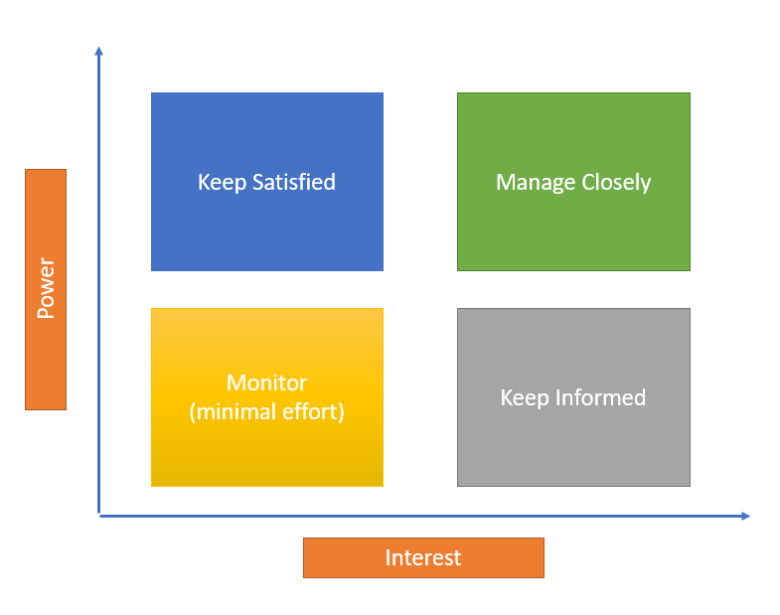

**Keep Satisfied:**

Chief Technology Officer

Vice President of Artificial Intelligence

**Manage Closely:**

AI Product Owner

Top Consumer Stakeholders

Trialist Club

Subject Matter Expert Consultants

**Monitor:**

Data Analytics Teams

Other intra-firm teams with relevant project experience

**Keep Informed:**

Data Analytics and Artificial Intelligence teams in the industry

Potential consumers

**Scheduled Meetings:**

1. **Firm Executives**
   1. Firm executives should be regularly met with to ensure that project goals, resources, needs, and more are well communicated and understood along the chain of management. The project manager will meet with the relevant executives at the end of each iteration to update progress and help with roadblocks.
2. **Trialist Clubs**
   1. The clubs that have been identified and agreed to trials will be important to meet with after the initial execution of the project. Leading up to the trial period, the project manager and lead data scientist will meet with members of the clubs data analytics team to review the features of the product, and how they should utilize it during the trial. After the trial is complete the clubs team, coaching staff, and front office will meet with the product owner and project manager to understand the quality and needs of the project.
3. **Subject Matter Experts**
   1. SMEs should be consulted as needed. In the very beginning phase of the project, they should be met with on a weekly basis so that they can guide the project before it goes down the wrong path.

## **STAKEHOLDER IDENTIFICATION OUTPUTS**

Stakeholder identification is distinguishing which parties are classified as stakeholders in a project, either because they can influence the project or because they are directly affected by the result. A stakeholder analysis is the process of identifying who the key stakeholders are before the project commences.

### **Stakeholder Register**

Primarily, the stakeholder register document assists in identifying, assessing, and classifying the project stakeholders. Therefore, the stakeholder register should be created during the initial planning process, mindfully using available tools. As a project management tool, these registers imply information like the stakeholders' interests, communication preferences, and influence.

The Stakeholder Register includes information about key individuals and groups with an interest in the FootyIntel Artificial Intelligence project.

|  |  |  | **Stakeholder Register** |  |  |  |
| --- | --- | --- | --- | --- | --- | --- |
| **Project Name:** | FootyIntel AI |  |  |  |  |  |
| **Project Phase:** | Project Initiation |  | **Date:** | 11/12/2023 |  |  |
|  |  |  |  |  |  |  |
| **Name of Stakeholder** | **Department** | **Role in Project** | **Type of Communication** | **Expectations** | **Interests** | **Influence on Project Outcome** |
| Chief Technology Officer | Technology Executive | Project Sponsor | In-direct from PMand directly from VP of AI | A successful and efficient execution of the project. | Technological and Financial Success | Has the capabilities to expand or shrink resources for the project |
| VP of AI | Technology Executive | Project Sponsor | Directly from Product Owner | A successful and efficient execution of the project. | Technological success and ability to utilize in other projects | Has the capabilities to expand or shrink resources for the project |
| Product Owner | Technology Executive | Project Sponsor | Directly from PM and Lead Data Scientist | Successful execution of the project | Financial success of the project, ability to sell and grow the product and firm | Can help the team with resources, management, consultation, relationships, stakeholder management, and more. |
| Trial Club | Professional Football Club | Test Stakeholder | Directly from PM and Lead Data Scientist | Utilize and test advanced technology and understand use cases | Consumer-related interest - first to utilize when the product is completed. | Has great influence on the actual services provided by the product. Will indicate what works and is useful for their purposes. |
| Potential Consumers | Other Professional Football Clubs | Consumer Stakeholder | Directly from Product Owner | Give input that will affect the project and its services | Consumer-related interest - giving advice that will ultimately help them. | Less influence than the trial club but still will be extremely important in understanding which specific services should be created and how |
| Known Analytics Teams | Analytics Teams of Professional Football Clubs | Future Users | Directly from Product Owner | Give input that will affect the project and its services | Subject Matter consultation and preview of new technology | Will be categorized as stakeholders and subject matter experts - can provide further detail into the process behind consumers. |

### **Project Management Plan Updates**

When stakeholders are identified at the very beginning of a project, there will not be updates to the project management plan. As the project progresses, any change to the project management plan goes through the organization’s change control process via a change control request. Components that may require a change request for the project management plan include but are not limited to:

* Requirements management plan.
* Communications management plan.
* Risk management plan.
* Stakeholder engagement plan.

## **RISK RESPONSE PLANNING**

For each major risk, one of the following approaches will be selected to address it:

* **Avoid** – eliminate the threat by eliminating the cause
* **Mitigate** – Identify ways to reduce the probability or the impact of the risk
* **Accept** – Nothing will be done
* **Transfer** – Make another party responsible for the risk (buy insurance, outsourcing, etc.)

For each risk that will be mitigated, the project team will identify ways to prevent the risk from occurring or reduce its impact or probability of occurring. This may include prototyping, adding tasks to the project schedule, adding resources, etc.

For each major risk that is to be mitigated or that is accepted, a course of action will be outlined for the event that the risk does materialize in order to minimize its impact.

## **STAKEHOLDER MONITORING, ENGAGEMENT, AND REPORTING**

The stakeholder engagement on a project will be tracked, monitored and reported throughout the project lifecycle. A stakeholder prioritization will be developed and maintained by the project team and will be reported as a component of the project status reporting process for this project. All project stakeholders will be analyzed for their possible impact to the risks. Management will be notified of important changes to stakeholder status as a component to the Executive Project Status Report.

# **TOOLS AND PRACTICES**

The Project Stakeholder Register will be maintained by the project manager and will be reviewed as a standing agenda item for project team meetings.STAKEHOLDER ENGAGEMENT PLAN APPROVAL

The undersigned acknowledge they have reviewed the **stakeholder Engagement Plan** for the FootyIntel AI project. Changes to this Plan will be coordinated with and approved by the undersigned or their designated representatives.

| Signature: |  | Date: | 11/12/2023 |
| --- | --- | --- | --- |
| Print Name: | Eric Wnorowski |  |  |
| Title: | Project Manager |  |  |
| Role: | Project Manager |  |  |

| Signature: |  | Date: | 11/12/2023 |
| --- | --- | --- | --- |
| Print Name: |  |  |  |
| Title: | Product Owner |  |  |
| Role: | Project Sponsor |  |  |

| Signature: |  | Date: | 11/12/2023 |
| --- | --- | --- | --- |
| Print Name: |  |  |  |
| Title: | VP of Artificial Intelligence |  |  |
| Role: | Project Sponsor |  |  |

| Signature: |  | Date: | 11/12/2023 |
| --- | --- | --- | --- |
| Print Name: |  |  |  |
| Title: | Chief Technology Officer |  |  |
| Role: | Project Executive |  |  |

**APPENDIX A: REFERENCES**

The following table summarizes the documents referenced in this document.

| **Document Name and Version** | **Description** | **Location** |
| --- | --- | --- |
| 4.1 Project Charter Plan | Project charter is issued by the Chief Technology Officer & Vice President of Artificial Intelligence Software. The document is written to ensure a common understanding between the project sponsors, the product owner, the project manager, the project team, and the key company stakeholders. | Google Drive Key Documents Folder |
| 5.3 Collect Requirements Plan | This Collect Requirements Plan defines how requirements associated with the *FootyIntel AI* project will be identified, analyzed, and managed. It outlines how collect requirements activities will be performed, recorded, and monitored throughout the lifecycle of the project and provides templates and practices for recording and prioritizing requirements. | Google Drive Key Documents Folder |
| 5.5 Create WBS Plan | The WBS is a deliverable-oriented hierarchical decomposition of the work to be executed by the project team to accomplish the project objectives and create the required deliverables. It organizes and defines the total scope of the project. | Google Drive Key Documents Folder |
| 5.15 Resource Management Plan | This plan defines how resources associated with the *FootyIntel AI* project will be identified, analyzed, and managed. It outlines how resource management activities will be performed, recorded, and monitored throughout the lifecycle of the project and provides templates and practices for recording and prioritizing risks. | Google Drive Key Documents Folder |

**APPENDIX B: KEY TERMS**

The following table provides definitions for terms relevant to the Risk Management Plan.

| **Term** | **Definition** |
| --- | --- |
|  |  |
|  |  |
|  |  |